Sunshine Coast Regional Jobs Committee
Regional Analysis Report
The content of this report should contribute to the direction and focus of the Annual Action Plan.

Project Details
Funded organisation | Regional Development Australia Moreton Bay & Sunshine Coast (RDAMBSC)
Project Manager | Tracey Coobula
Reporting period | March 2026
Report endorsement | Name: Andrew Eves-Brown  Title: Chair, Sunshine Coast Regional Jobs Committee  Date endorsed: March 2026

Regional overview

Geographic and demographic profile:
- Provide details of the location and boundaries of the region (LGAs).
- Provide details of population statistics, including age, cultural diversity and workforce demographics.
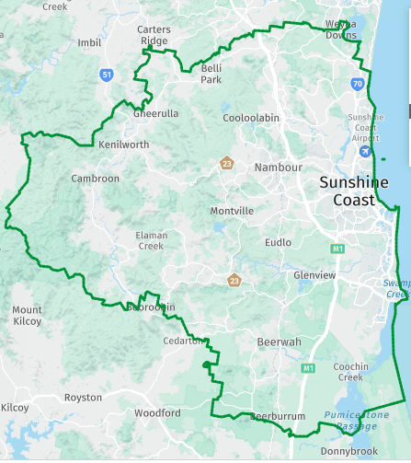
Sunshine Coast Regional Jobs Committee covers the LGA of Sunshine Coast Regional Council. The Sunshine Coast Regional Council area borders the Noosa Shire in the north, to the City of Moreton Bay in the south, and bounded by the Gympie and Somerset regions to the west, encompassing a coastal and hinterland area that includes Caloundra, Maroochydore, Coolum, Maleny, and the Glass House Mountains.
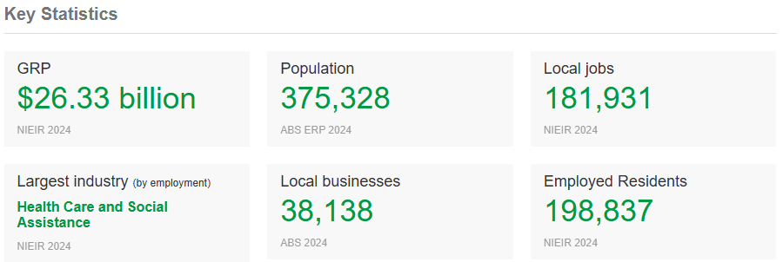

The Sunshine Coast LGA region had an estimated resident population of approximately 375,000 people as of June 2024, continuing strong annual growth from the 2021 Census population of 342,541 living in 149,010 dwellings, with an average household size of 2.46. The region’s age profile is older than the Queensland average, reflecting its appeal as both a lifestyle and retirement destination. Around 17 per cent of residents are aged 0–14 years and 11 per cent are aged 15–24, while 44 per cent of the workforce is aged 45 years or older, compared with 41 per cent across Queensland.
Employment by age group from the SA4 (Sunshine Coast and Noosa LGAs) ABS Labour Force, Australia, Detailed (RM1, February 2024) shows the highest concentration in the 25–34 year cohort (approximately 12,900 employed persons), followed by 15–24 years (11,000), 35–44 years (9,800), 45–54 years (7,900), 55–64 years (7,200) and 65 years and over (5,000). This distribution highlights both strong youth and early-career participation and a substantial mid-to-late-career workforce consistent with the region’s balanced employment mix.
Cultural diversity is moderate, with 20.7 per cent of residents born overseas and 2.3 per cent identifying as Aboriginal and/or Torres Strait Islander. The total labour force in 2024 numbered around 232,000 people, with an unemployment rate of 4.7 per cent and participation rate of 59.6 per cent, slightly below the Queensland average due to the region’s older demographic. Employment is broadly diversified, though concentrated in health care and social assistance (19 per cent of workers), retail trade (11 per cent), and construction (10 per cent), reflecting the Sunshine Coast’s position as one of Queensland’s fastest-growing regional economies.
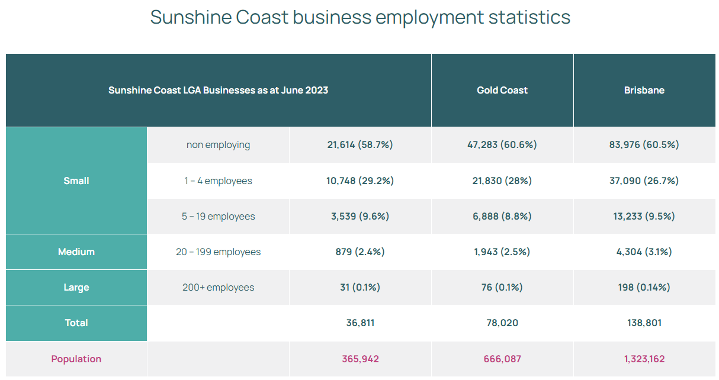
Sources: Australian Bureau of Statistics, Census of Population and Housing 2021 (usual residence); ABS Labour Force, Australia, Detailed, RM1 – Labour Force Status by Age, Labour Market Region (ASGS) and Sex, February 2024 (6291.0.55.001); ABS Regional Population Growth, Australia 2024 (3218.0).
Local Workforce Demographics
The local workforce is made up of all the people who are employed in the local area, regardless of where they live. Local workers statistics reveal how the characteristics of the local workers in Sunshine Coast vary between each industry sector and indicates specific industry sector local workers requirements and employment opportunities.

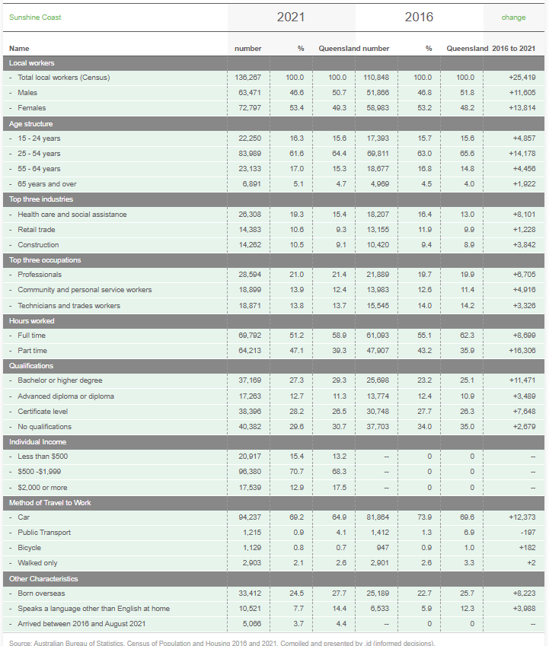

Regional Migration
The Sunshine Coast continues to attract the largest net migration to regional areas, with Greater Geelong second and the top 5 regions largely unchanged. The Sunshine Coast remains the country’s top regional migration hotspot, attracting the largest numbers, in net terms, among all of Australia’s regions. For each of these net migration hotspots, the bulk of the net migration is coming from capital cities, rather than from other regions. This is the 11th quarter since December 2022 that Sunshine Coast has led Australia as the number one location for net regional migration putting massive pressure on an already scare housing and rental supply stock.
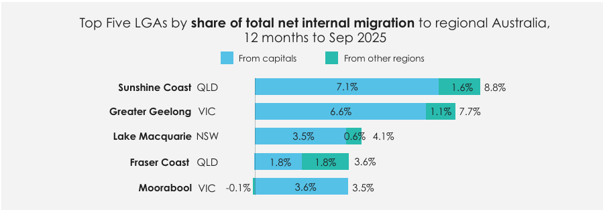 Source: RMI September 2025 Report

Geographic and demographic profile of RDA Moreton Bay and Sunshine Coast’s remit

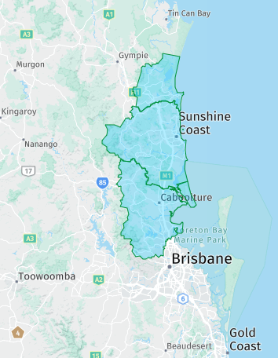
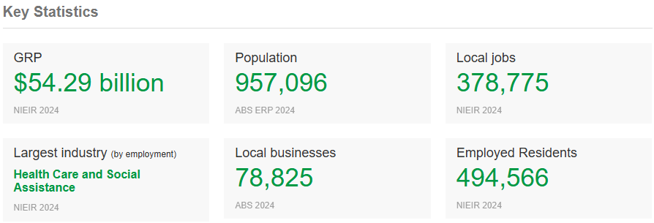
The RDA Moreton Bay and Sunshine Coast Region is located in south-east Queensland, covering an area from 20-120 kilometres north of the Brisbane CBD and includes three LGAs; Moreton Bay, Sunshine Coast and Noosa. The Region is bounded by the Gympie Regional Council area in the north and north-west, Brisbane City to the south, and the Somerset Regional Council area in the south-west.

The Sunshine Coast Regional Jobs Committee will greatly benefit from the economic and workforce overview and partnerships that RDAMBSC has with each LGA as this critical northern SEQ corridor continues to grow and diversify.

Source: About the economic area | RDA Moreton Bay and Sunshine Coast | economy.id

Economic profile:
- What are the key industries and employment sectors within the region?
- List the regional economic priorities and growth trends within the region.

The key industries and employment sectors within the Sunshine Coast region (based on 2024 data and the economy.id and ABS sources) show a region dominated by health, construction, and service-based employment, with emerging diversification into knowledge and technology fields.

The largest employing sector is Health Care and Social Assistance, accounting for around 19 per cent of the workforce, reflecting the region’s ageing demographic and major investments in the Sunshine Coast Health Precinct at Birtinya. Retail Trade (11 per cent) and Construction (10 per cent) remain core employers, supported by continued population growth and housing demand. These three sectors collectively underpin much of the region’s $17 billion contribution to the Queensland economy.

Beyond these foundations, growth has been evident in Professional, Scientific and Technical Services, Education and Training, and Accommodation and Food Services. These industries align with broader regional trends highlighted by Jobs Queensland and economy.id, which identify sustained demand for professionals, educators, and service workers.

Advanced manufacturing is emerging as a future-facing sector, particularly in aerospace, medical technology, food and beverage production, and renewable energy. The Sunshine Coast is home to multiple industrial precincts—including the Sunshine Coast Industrial Park, Kunda Park Industrial Estate, Coolum Industrial Park, Airport Business Park, and Aura Business Park—supporting high-value production and logistics activity. The Peregian Digital Hub and USC Innovation Centre are also enabling growth in AI, digital technologies, and cybersecurity, positioning the region as an emerging innovation hub in South East Queensland.

Tourism continues to play a significant role, contributing 10–15 per cent of regional economic output, with strong linkages to hospitality, retail, and cultural sectors. However, the region’s future growth strategy increasingly emphasises innovation, advanced industries, and smart specialisation—moving beyond a traditional tourism and construction economy.

Sources: Australian Bureau of Statistics, Labour Force, Australia, Detailed, February 2024; economy.id Sunshine Coast (Industry Sector Analysis, accessed 2024); Sunshine Coast Regional Jobs Committee, Regional Analysis Report (2025).

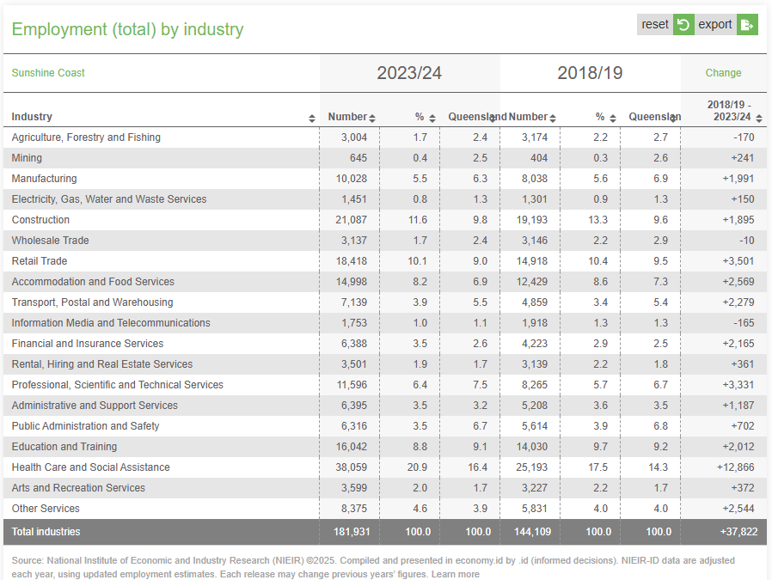
Sunshine Coast Council Regional Economic Development Strategy 2013 – 2033
In 2013, the REDS championed the identified seven high-value industries and the game changer projects. Today, with a more diversified and sophisticated economy, a more holistic approach to economic development is required that expands upon the seven high-valued industries to include six broad economies within the larger regional economy:
Knowledge Economy: the knowledge economy includes the high-value industries of professional services, education and research as well as health and wellbeing. These industries have delivered value for the region and will continue to aid in the region’s transition.
Digital Economy: the digital economy consists of a range of high technology businesses leveraging the Sunshine Coast’s digital infrastructure and includes cyber security, ICT, defence, screen and others.
Production Economy: the production economy represents the high-value industries of aviation and aerospace as well as food and agribusiness, but is expanded given the increasing diversity of advanced manufacturing incorporating a range of innovation, including the pharmaceutical and biotech production sector, amongst others.
Green Economy: the green economy includes the high-value industry of cleantech as well as adding other emerging areas of circular economy, green energy, smart construction and decarbonisation.
Visitor Economy: the visitor economy encompasses the high-value industries of tourism and sports as well as recognising the important future role that major events, international students as well as new visitor experiences can play in the future economic development of the region.
Place Based Economy: the place based economy includes a diverse range of industries and sectors that are necessary to build diverse and activated precincts and places across the region and includes construction and trades, night-time economy, retail and hospitality as well as music and the creative industries.
These six economies are inclusive of new and emerging industries as well as the previous seven high-valued industries. There are strong connections, links and collaborations across the six economies, however, they stand as broad industry clusters capturing a range of supply chain and interrelated relationships. Resolution of the significant housing and transport infrastructure challenges facing the Sunshine Coast will be critical to reaching the identified 2033 goals.

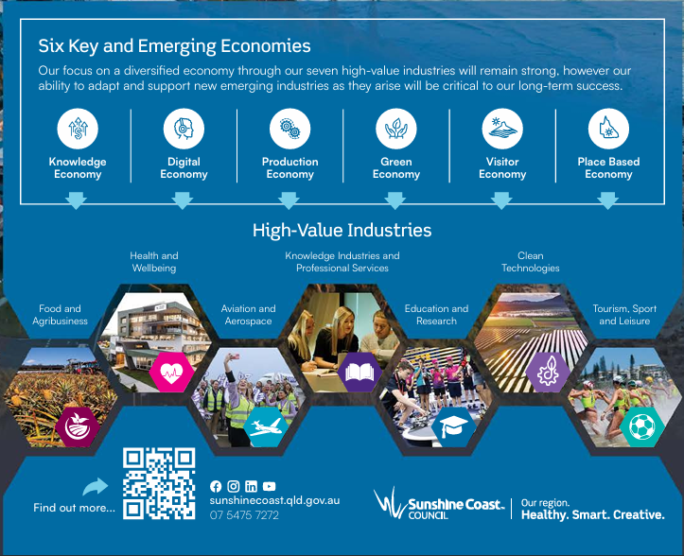
Anticipating Future Skills for Sunshine Coast 2027-28 (SA4 Level)
High population growth is projected to drive high employment growth in the Sunshine Coast region, with nine industries projected to experience growth above the state average by 2027–28. Health care and social assistance is set to be the largest-employing and fastest-growing industry. The top four industries are projected to employ over half of the region’s total workforce.
Source: sunshine-coast-regional-summary-afs.pdf
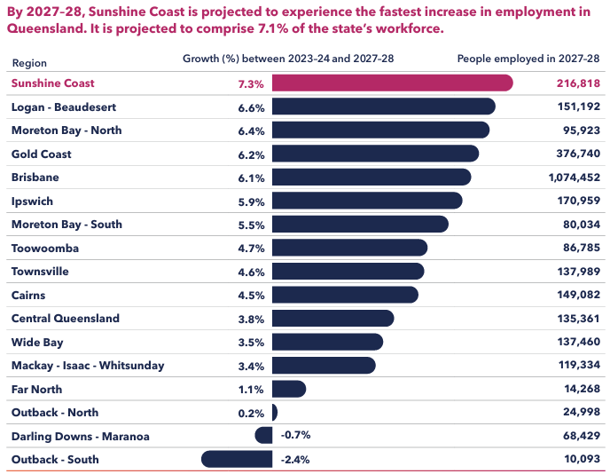
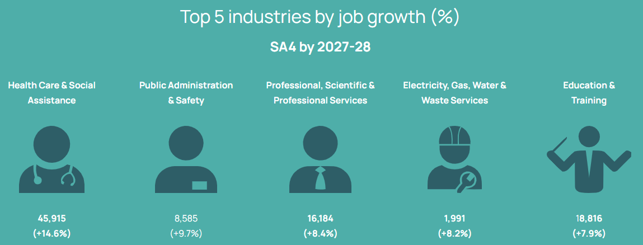
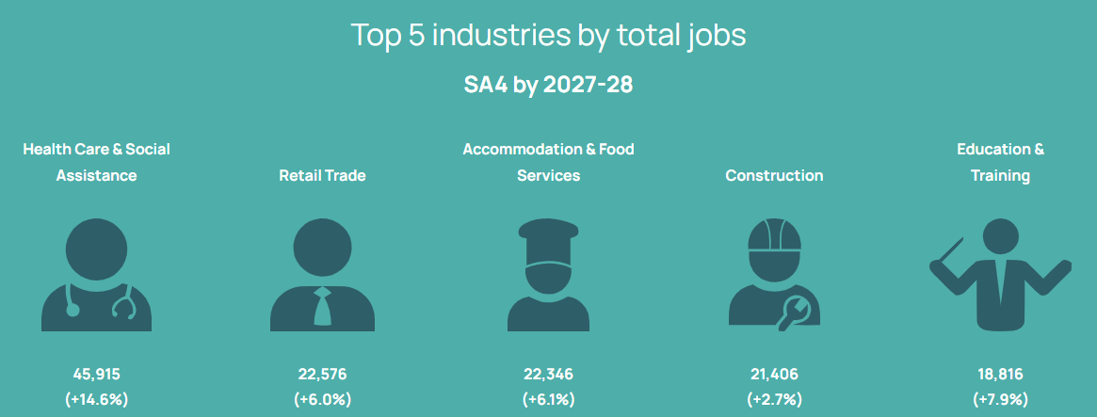

Community Profile:
- Social and cultural characteristics
- Community strengths and challenges
Social and Cultural Characteristics of the Sunshine Coast:
Socially and culturally, the Sunshine Coast is a fast-growing lifestyle region on Kabi Kabi and Jinibara Country, with a mix of retirees, families and professionals; strong beach, hinterland, community and volunteer cultures; an increasingly multicultural, creative and environmentally-conscious identity; and underlying challenges around growth, housing and equity.
1. First Nations foundations
- The Sunshine Coast is, first and foremost, the Country of the Kabi Kabi / Gubbi Gubbi people and the Jinibara people.
- Their connection to land, water and stories underpins the region’s identity – from place names and language to caring-for-Country practices and cultural tourism.
- Recent native title determinations (Kabi Kabi in 2024; Jinibara earlier) have strengthened recognition and co-management of land and cultural rights across large parts of the region.
2. Lifestyle and migration culture
- The Coast is one of Australia’s fastest-growing lifestyle regions and has recently topped national indices for internal migration – lots of people moving from capital cities for “sea change / tree change” reasons.
- Key drawcards: beaches, national parks, a slower pace, small-business opportunities, and a strong focus on outdoor living and wellbeing.
- There’s a noticeable “liveability” culture – flexible work, cafés as offices, surf before/after work, high participation in sport and recreation.
3. Multicultural & migration stories
- Historically the Coast attracted British and European migrants; more recently it’s becoming increasingly multicultural, with people arriving from Asia, the Pacific, Africa and the Americas, as well as other Australian states.
- Community centres in places like Nambour, Baringa and Caloundra run ESL classes, settlement programs and cultural connections programs, which support newer migrant communities and add to local diversity.
4. Strong place-based identity: beach + hinterland
Culturally the Coast divides (loosely) into:
- Coastal strip (Caloundra–Maroochydore–Mooloolaba–Coolum):
  - Surf and beach culture, tourism, hospitality, apartment living, night-time economy, retail.
  - High value placed on fitness, surf, kite/windsurfing, coastal walking paths, café culture and markets.
- Hinterland (Maleny, Montville, Mapleton, Blackall Range, etc.):
  - More rural and village-style, strong arts, crafts, alternative/holistic lifestyle and small-scale farming culture. Australian Bureau of Statistics+1
5. Arts, culture & events
- The region has an evolving creative industries ecosystem, backed by a dedicated Creative Arts Plan 2023–2038 and arts funding programs.
- There’s a strong culture of:
  - community theatre, live music and festivals (e.g. music, food, surf and arts events),
  - markets (Eumundi, Caloundra, Mooloolaba, etc.),
  - galleries, studios, writers and designers.
- Creative work is increasingly recognised not just as “lifestyle” but as part of economic development and regional branding.
6. Environment, sustainability & “biosphere” thinking
- With national parks, marine parks and hinterland reserves, environmental values are big.
- Local narratives emphasise conservation, low-impact living, local food systems and eco-tourism – especially around coastal dune systems, waterways, and the three neighbouring Sunshine Coast, Noosa and Great Sandy UNESCO biosphere reserves.
- Council strategies and marketing frame the Coast as a “clean and green” region, and that seeps into community culture: recycling, local produce, outdoor education, and activism around development and climate issues.
8. Community, sport & everyday social life
- Sunshine Coast will host a selection of sports and an athlete’s village as part of the 2032 Olympic Games
- High engagement in sport and recreation – surf clubs, Nippers, rugby league and union, AFL, netball, touch, triathlon, park runs, golf, bushwalking and mountain biking.
- Strong volunteer culture through surf lifesaving, service clubs, environment groups, arts, and community events.
- Social life still tends to be local and community-based – schools, sports clubs, churches, markets, and local cafés, with a modest but growing night-time and foodie scene, especially around Mooloolaba and Maroochydore CBD.
9. Social challenges alongside the lifestyle image
Behind the “sunny” branding, there are also social issues that shape the region:
- Housing stress and affordability due to rapid population growth and limited rental supply.
- Service pressure in health, aged care and transport.
- Socio-economic contrasts between wealthy coastal areas and lower-income pockets inland or in older suburbs

Community Strengths:
- Highly liveable region with strong social cohesion
The Sunshine Coast maintains one of the highest lifestyle and wellbeing ratings in Queensland. Residents report strong place attachment, high volunteer participation, and deep community engagement, factors that underpin the region’s attractiveness for families, professionals, and retirees.
- Diversified education and training ecosystem
The presence of UniSC, TAFE Queensland East Coast, and multiple private providers enables a broad base for workforce development. Strong collaboration between industry, local government, and education providers, helping align training with critical job needs in health, digital, and manufacturing sectors.
- Growing innovation culture
Investment in hubs such as the Peregian Digital Hub, Maroochydore City Centre Smart Precinct, and USC Innovation Centre supports entrepreneurship and technology adoption. These hubs are seen as key enablers for transitioning from a service economy to a knowledge-driven economy.
- Natural environment and lifestyle as economic assets
The combination of coastal and hinterland environments, sustainable development planning, and environmental protection contributes to both resident satisfaction and the region’s appeal to skilled migrants, students, and investors.
- Collaborative regional governance
Strong coordination between Sunshine Coast Council, Noosa Council, City of Moreton Bay, Jobs Queensland, and regional partnerships fosters a shared strategic vision and ability to mobilise around workforce and economic challenges.

Community Challenges:
- Workforce and skills shortages
Persistent shortages are evident in health, construction, early childhood education, and emerging technology sectors. Training pipelines are struggling to keep pace with employer demand, particularly for mid-career reskilling and digital capabilities.
- Housing affordability and cost-of-living pressures
Rapid population growth and limited supply of affordable rentals have intensified housing stress. This affects labour mobility, workforce retention, and the ability of younger residents and essential workers to remain in the region.
- Transport and infrastructure constraints
Congestion, limited public transport connectivity, and reliance on private vehicles constrain access to employment hubs. Infrastructure investment remains a key dependency for future growth, particularly around the new Maroochydore CBD and Caloundra South.
- Demographic imbalance
The region’s older population (median age ~44) and relatively low participation rate (≈59.6 %) reduce overall labour-force capacity. Attracting and retaining younger workers is a continuing focus.
- Economic concentration risk
Despite diversification, the local economy remains sensitive to fluctuations in construction, tourism, and retail activity. Sustaining growth in higher-value, export-oriented industries is central to achieving resilience.

Key issues and opportunities

Economic challenges:
- What are the barriers to business growth and workforce development?
- What are the impact/s of economic trends on the region?
Barriers for Business Growth and Workforce Development
In the 2023 Business Survey conducted by Sunshine Coast Council, respondents identified some significant economic barriers and challenges affecting businesses in the region.
The lack of affordable housing and the limited diversity of available housing options are making it incredibly challenging for companies to attract and retain top talent. At the same time, there are serious issues with transportation infrastructure that are impeding both movement within the region and access to the region as a whole. Heavy rail connections do not reach major centres and mass transit options are insufficient, leaving many residents struggling to get around or access jobs without a motor vehicle. Addressing these key challenges will be essential to promoting sustainable economic growth and development in the Sunshine Coast in the years ahead.
There are a range of secondary challenges that affect many businesses and specific industries, including:
- Lack of available and suitably skilled staff (which is linked to the housing issue, i.e. staff can be identified and hired but can struggle to find local housing so cannot take up the position)
- A deficiency of night-time economy activities which includes a lack in diversity of night-time activities, such as restaurants, cafes and bars but also various art and cultural activities. There is a strong connection between arts and culture, the night-time economy and talent attraction. Increasing the arts and cultural offerings can support an increase in the night-time economy, which can aid in future talent attraction.
- The challenges from climate change are significant, and the current response in terms of renewable energy and other mechanisms to support sustainability is not enough
- Lack of a breadth and depth of industry (more diversity), but also including larger firms that would provide benefits including allowing for career progression within the region and a critical mass to support more commercial development
- Retaining the region’s unique character, which locals highly value, is a challenge due to the influx of new residents as well as the sheer size of the region (and its projected future size)
- Some planning restrictions and other regulatory aspects have provided a barrier to some business growth and expansion
- Potential conflict with parts of the community that do not believe growth is required (especially retired cohort)
- Not all parts of the community have benefited from the economic growth over the last 10 years and it will be important to be more inclusive and ensure that economic benefits flow to all parts of the community
- Pockets of poor mobile phone coverage or internet connectivity limiting productivity and growth potential.
Many of these issues are connected and interrelated. The liveability of the region can be enhanced through addressing transportation issues within the region (Mass Transit) and increasing the attractiveness of various Gateway Precincts through place making.
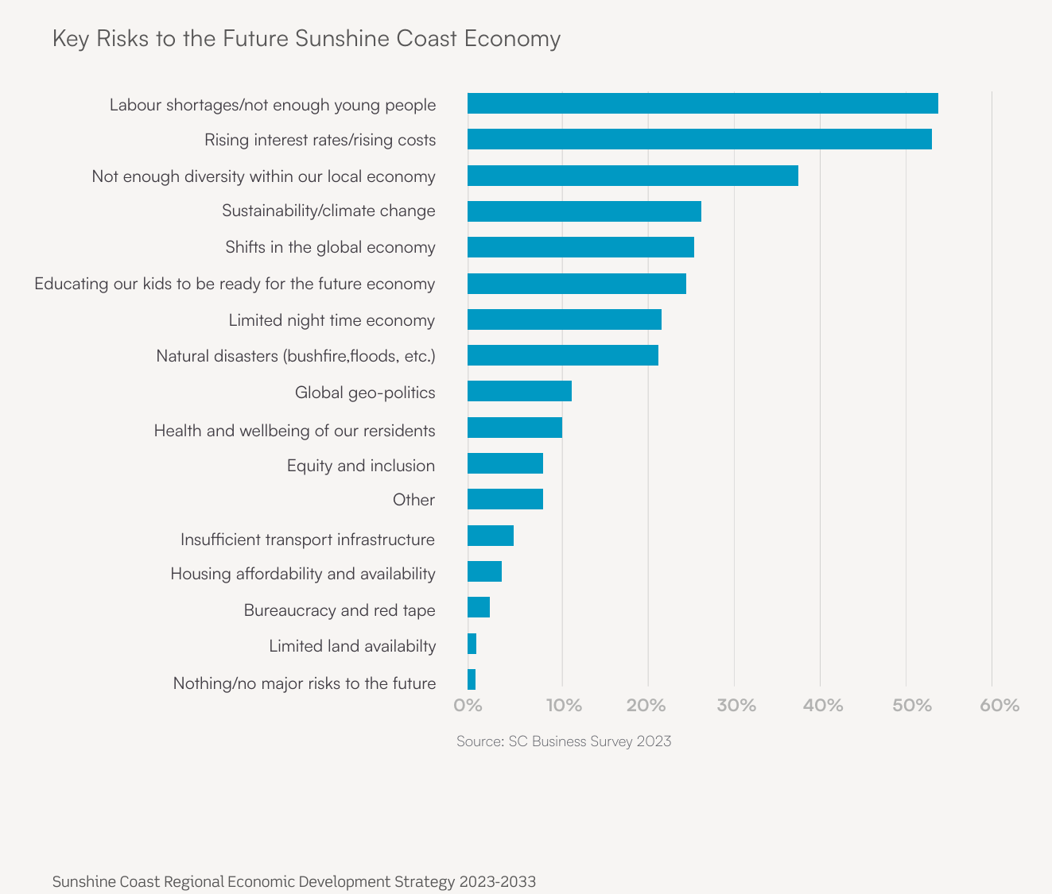

Impacts of Economic Trends on the Region
The region has strong growth and managing growth of existing and new industries is a major challenge. There is overreliance on existing industries (health, construction and tourism), and limited levers to pivot into new innovative economies. The region struggles to address short-term industry and workforce needs and at the same time seed medium-term growth trajectories and ambitions.
Carving out an innovative future for the region must step well beyond efficiency optimisation of existing resources, beyond projecting growth from contemporary activity, and instead look at how place-based strengths can be discovered, prioritised and advanced through value-creating collaborations. For it is only through a solid, working partnership between governments, industry, community and the research and training sector that long-term, sustainable growth can be achieved.
The major trends impacting business growth and workforce development, as highlighted in interviews with regional stakeholders, stem from:
- Workforce characteristics – labour shortages, skills gaps and workforce retention;
- Economic and investment factors – limited investment, development of entrepreneurial and innovation capability, and need to increase industry specialisation;
- Infrastructure matters – housing, transportation and innovation support.
As mentioned, the region relies heavily on tourism and health in terms of productive sectors, with an overall contribution of around $17 billion to the Queensland economy. Tourism accounts for approximately 10-15 per cent of regional domestic product, with health care and ageing services accounting for roughly 19 per cent of the region’s employment. Overall expenditure on health care services is estimated at over $1 billion annually.
While strong drivers in economic terms, tourism and health do not stand out as innovative sectors that give the region a competitive advantage compared to the rest of Queensland or Australia.
Unsurprisingly, Construction and infrastructure development is the third driving sector in the region. This is seen as a prolonged growth sector, spurred by a continuous influx of people to the region and the upcoming Olympics which requires an upgrade in transport and accommodation.
One of the major emerging growth trends being focused on in the region is that of Aerospace. RDAMBSC recently conducted an initiative through ANU Inspace Agency: The Space + Place pilot, The findings demonstrate that the City of Moreton Bay, Sunshine Coast and Noosa Local Government Area are primed to play a central role in Australia’s emergence as an aerospace sector leader. In order to achieve this potential, the region requires an evidence-informed and highly targeted strategy for aerospace industry investment and development. These recommendations home in on three immediate, priority sector opportunities that leverage the existing workforce skills, locational benefits and technology environments unique to the area. Key regional opportunities for priority investment and growth are:
Downstream aerospace sectors:
1. Data analytics and digital infrastructure: Transforms satellite data into actionable insights using AI, cloud computing and cybersecurity, supporting regional monitoring and resource management. Leverages existing regional infrastructure and capabilities.
2. Geospatial and satellite data services: Uses remote sensing and GIS for disaster management, precision agriculture and climate adaptation with early-warning systems and environmental monitoring. Leverages existing regional infrastructure and expertise, including in universities, government and industry. Encouragingly, collaboration is already being driven through Sunshine Coast Council in the geospatial area.
Upstream aerospace sectors:
3. Advanced manufacturing for micro/nanosatellites: Focuses on precision engineering and additive manufacturing for small-scale satellite production, strengthening local industry and national defence supply chains. Leverages regional strategies for technology industry growth, with a focus on advanced manufacturing. Opportunities to expand manufacturing to incorporate a range of payloads.

Opportunities:
- What are the emerging industries and growth sectors within the region?
- What are the opportunities for business growth and workforce development in the region?
- Are these solutions aligned with regional economic priorities?
See ‘Sunshine Coast Council REDS’ plan in previous section for lists of emerging and growth industries and economies

Opportunities for Business Growth and Workforce Development
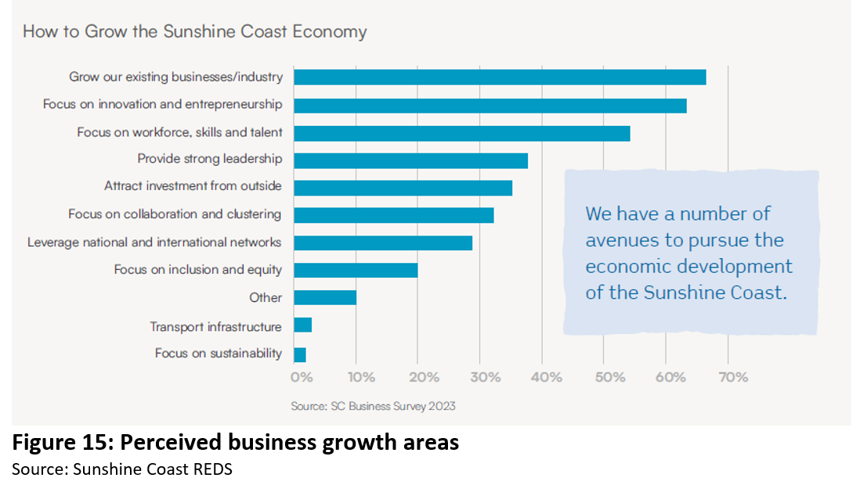
The Sunshine Coast region is prosperous, thriving and buoyant. It has a growing and increasingly educated population, favourable economics, wonderous lifestyle options, and a mega event on the horizon in terms of the 2032 Olympics. With proactive leadership, the region can progress from trading solely on natural rather than entrepreneurial assets, no longer undervaluing its potential, development and contribution.
Interim insights from recent research have canvassed current contexts and options for industry and skills innovation and development. Existing regional assets and strengths are clear, as is the opportunity to leverage augmented growth from preparation for the Olympics. What is a focus now, are the steps being taken to prioritise investment in distinctive regional assets.
Innovation flows not only from good planning and from natural and built infrastructure, but most particularly from skills and collaboration.
There is evident collaboration between the two local government areas (LGAs) which sit either side of the Sunshine Coast, with Moreton Bay to the South and Noosa to the North. This is significant and conveys ongoing potential for governance directions and alignments capable of charting bold strategic development.
Within the region there is also a strong push to turbo charge advanced manufacturing as a cornerstone for the future of the region’s industrial basis. It is clear to see this as an area of competitive industrial growth.
The advanced manufacturing sector is driving innovation. There is a clustering of small and larger companies in the fields of aerospace, medical technologies, food processing and renewable energy. Noticeable is the strong support of both local and state governments, combined with input from the University of the Sunshine Coast and TAFE Queensland. This has resulted in a network of innovation hubs across the LGAs.
Notably, USC Innovation Centre/Collider brings together advanced knowledge through targeted research with industrial partners and an active accelerator program where ideas are translated into concrete projects in a six months’ time frame (Air to Sea program). Co-working spaces exist, and students are actively engaged with projects such as autonomous vehicles and eVTOL (Vertical Takeoff and Landing).
Currently, Sunshine Coast and Noosa are home to several industry parks: Sunshine Coast Industrial Park (Caloundra), Cooroy- Industrial Park, Palmview Industrial Estate, Yandina Industrial Estate, Kawana Industrial Park, Coolum Industrial Park, and Kunda Park. These are supported through Invest Sunshine Coast offering resources to help companies establish in the region.
The Moreton Bay region also boasts a number as well-established industrial parks including Brendale Industrial Precinct, Corporate Park East – Caboolture, North East Business Park, New Base Business Park and Elimbah East Southern Precinct due to finish soon.

There are also industry concentrations in the several areas. The following examples can be further grown as areas of smart skill specialisation:
- Aerospace: With high-precision manufacturing companies ranging from commercial to defence suppliers including: Helimods, Javelin Aerospace, Coastal Aviation, Raider Targetry, Sigma Aerospace Group, SunCoast Aero Engines, SC Aerospace, McDermott Aviation, Helitak, Airworks Aviation, Elexon Electronics, Tubeworx, Aviation Components, Omni Executive Aerospace and Life Flight
- Medical and biopharmaceutical: Medical devices and biopharmaceutical companies are realising rapid growth in the region including: Smartline Medical, Bundle of Rays, Coach Welly, Servatus, Australian Biotherapeutics, Terragen Biotech and BioCifer
- Food and beverage: The region offers a thriving food and agribusiness ecosystem with established players like McCormicks/Gourmet Garden, Sunshine & Sons, Coyo, Kilcoy Global Foods, The Country Chef Bakery Co, Hip Hops Brewers, Sunshine Coast Craft Brewery, Noosa Black Garlic, Coastal Fruits, Bask & Co, Mallory’s Tocino Jerky, My Berries, Comiskey Distillery, Maleny Cheese Factory, Maleny Food Co, Nutworks, Your Mates Brewing Co, Sunshine Coast Olive Oil, Maleny Diaries, Ginger Factory, Noosa Chocolate Factory and Heads of Noosa Brewing Co.
- IT/AI/Cybersecurity: Serious players include NEXTDC, IDCARE, Entag, Blue Seas and CyberMerc. UniSC offers a Master of Cyber Security and Forensics. CI-ISAC is building a global centre for cybersecurity on the Sunshine Coast and Noosa is positioning itself as an AI/IT cybersecurity hotspot. It builds on the Peregian Digital Hub’s established track record in AI education, which began in 2019 with an AI Cadetship for high school students. The recent addition of the AI Lab at the Hub’s upgraded facility has expanded these capabilities. Tokenizer, an initiative of the Peregian Digital Hub and funded by RDAMBSC, offers specialised programs for different community groups, including:
  - Special programs for school-aged children and teenagers, in the school holidays;
  - Upskilling support and mentoring for business leaders;
  - Technical workshops for professionals looking to upgrade their skills; and
  - Free AI workshops and helpdesk delivered via the Noosa Libraries Digital Leaders program.

Solutions:
- List unique solutions (not duplicated elsewhere) which can be delivered to address these challenges?
- Do these solutions represent or leverage other capacity across the region?
- Do these solutions align with regional economic priorities or other government priorities?
The Regional Jobs Committee (RJC) is refining its strategic focus to develop locally targeted workforce and skilling solutions that address critical skills shortages across key industry sectors. To ensure the 2026–27 Action Plan reflects current workforce needs and has strong industry support, the RJC will undertake direct consultation forums with industry and community stakeholders to validate existing intelligence on workforce barriers, skills gaps and potential solutions.
The forums will prioritise four sectors identified as having the highest employment demand and growth potential within the region: Health and Care | Education and Training | Construction | Manufacturing
In February 2026 the RJC will host four Industry Skills Forums bringing together employers, educators and community representatives from four critical sectors. These forums will focus on identifying the most significant barriers to workforce participation, current and future skills gaps, and industry-led solutions that can inform regional workforce initiatives. We will also validate the priorities we have identified from industry.
To respond to these challenges, the RJC will deliver initiatives across five strategic solution areas:
- Consultation – Ongoing engagement with industry and community to ensure workforce programs remain responsive to evolving skills needs.
- Grow Your Own – Attraction and awareness initiatives targeting students, educators, parents, First Nations communities and migrant cohorts to build future workforce pipelines.
- Building Inside Up – Workforce capability development focused on upskilling, leadership, AI literacy, workplace culture, wellbeing and internal career mobility.
- Strengthening Connections – Acting as a regional connector between government, industry and community stakeholders to align efforts and maximise workforce outcomes.
- Workforce Harmonisation – Supporting clearer education and training pathways through collaboration with institutions such as UniSC and TAFE Queensland and sharing best practices across Regional Jobs Committees.
Together, these actions will position the RJC to deliver coordinated, industry-informed workforce solutions that support regional economic growth, strengthen talent pipelines and improve workforce participation across priority sectors.

Embracing AI for Productivity Gains and Enhanced Skill Sets

How can the Sunshine Coast be a leader at building AI competence across workforce, looking at:
- Automating repetitive work – so people can focus on higher value tasks
- Supercharging knowledge work to utilise on-call research assistants and editors
- Better decision making with data to analyse patterns and large data sets
- Training, upskilling and knowledge transfer for micro-learning at pace with industry
- Enhanced creativity and innovation ideation
- Reducing burnout and improving job satisfaction, reducing churn
- Building HR, onboarding and instruction guides for streamlined workflows
Here’s how the alignment occurs across key policy layers:
The SCRJC’s focus on workforce development, innovation, and inclusive growth directly supports the Sunshine Coast’s 20-year Regional Economic Development Strategy (REDS 2013–2033) goals:
- A $33 billion economy by 2033, achieved through high-value industries and export growth.
- Creation of 100,000 new high-value jobs, particularly in health, education, digital, and advanced manufacturing.
- Increased household income to meet or exceed the Queensland average.
- The SCRJC’s focus, such as upskilling programs in health, construction, and digital sectors; stronger industry-training partnerships; and targeted engagement with youth and mature-age workers, are directly tied to these REDS objectives.

Alignment with Queensland Government Priorities:
At the state level, the SCRJC’s work sits squarely within the Queensland Workforce Strategy 2022–2032 and Good Jobs - Great Training Initiative, which aim to:
- Build a resilient and adaptive workforce.
- Strengthen pathways between school, training, and work.
- Support regional skills alignment through local partnerships (Industry Groups)
The SCRJC’s regional approach, collecting local labour-market data, identifying skill shortages, and coordinating employer-training solutions, implements this state framework at the local scale.
- The focus areas of health and care services, construction, advanced manufacturing, renewable energy, and digital technologies also mirror Queensland’s identified priority industries for sustainable growth, as outlined in the Queensland Advanced Manufacturing 10-Year Roadmap and the Queensland Jobs Fund.

Nationally, the SCRJC’s activities support several federal strategies:
- The Employment White Paper (2023), which prioritises inclusive participation, lifelong learning, and place-based workforce planning.
- The National Skills Agreement (2024–2028), which decentralises workforce planning and funding to regional collaborations like the SCRJC.
- The Net Zero 2035 and Future Made in Australia agendas, through initiatives that prepare workers for clean-energy and advanced manufacturing roles emerging across South-East Queensland.

In combination, these frameworks share the same intent: developing a skilled, adaptable, and regionally anchored workforce to drive sustainable economic growth. The SCRJC’s regional initiatives, workforce planning, education-industry alignment, and skills development, are local delivery mechanisms for both the Sunshine Coast REDS 2033 and Queensland’s Workforce Strategy 2032.
Sources: Sunshine Coast Regional Economic Development Strategy 2013–2033; Queensland Workforce Strategy 2022–2032; Australian Government Employment White Paper 2023; economy.id Sunshine Coast 2024 profile.

